Configuring Selenium Grid Across Multiple PCs

Sean McGrath, [sean.mcgrath@tcs.com](mailto:sean.mcgrath@tcs.com)

**Selenium Grid:**

Selenium Grid is a part of the Selenium Suite which allows for running multiple tests across multiple machines, browsers, and operating systems. The tests are run on a single machine called a *hub*, and executed on one or more machines called *nodes*. The benefit of Selenium Grid is that tests can be run on different browsers and operating systems in parallel, and it allows testers to save time in executing a test suite.

**Configuring Selenium Grid with One Hub and One Node**

To start simply, we will configure our grid with one hub and one node. We will refer to these machines as Machine H and Machine N_0, respectively. Remember there can only be one hub in a grid, as it is the centralized point for loading all tests. Each node is a Selenium instance that executes a test loaded onto the hub. To begin, first we must download the Selenium Standalone Server .jar file on each machine. As of this writing, the current version is 3.0.1.

<http://docs.seleniumhq.org/download/>

To finish install, simply save the .jar file onto each machine’s file system, we will just put ours directly on the C: drive.

**Launch a hub**

On Machine H, navigate to the root of H’s C: drive via the command prompt.

Enter following command on the command prompt:

java –jar selenium-server-standalone-3.0.0-beta2.jar –role hub

The hub should be launched and your command prompt should look similar to the following:

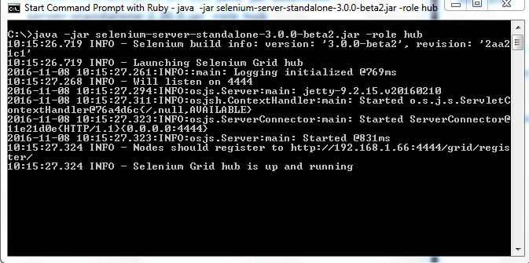

The hub defaults to run on port 4444, so on Machine H open a browser and navigate to

localhost:4444/grid/console

You should see something like this:

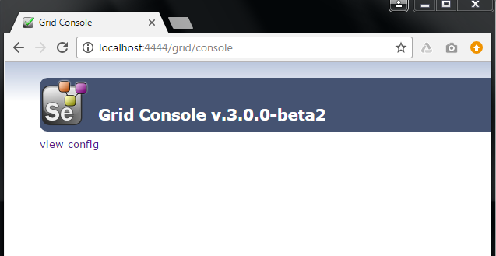

The Hub has been successfully launched!

**Launch a Node**

On Machine N_0, open command prompt and navigate to the root of N_0’s C: drive. Enter the following command:

Java –jar selenium-server-standalone-3.0.0-beta2.jar –role webdriver –hub http://<ip-address-of-Machine-H>:4444/grid/register –port 5566

Here we used port 5566, but you may use any free port you desire.